BÁO CÁO THỰC HÀNH LAB 1  
LẬP TRÌNH HƯỚNG ĐỐI TƯỢNG

# The Very First Java Programs

## *2.2.1* Write, compile the first Java application:

*Kết quả*

## 2.2.2 Write, compile the first dialog Java program

## 2.2.3 Write, compile the first input dialog Java application

## 2.2.4 Write, compile, and run the following example:

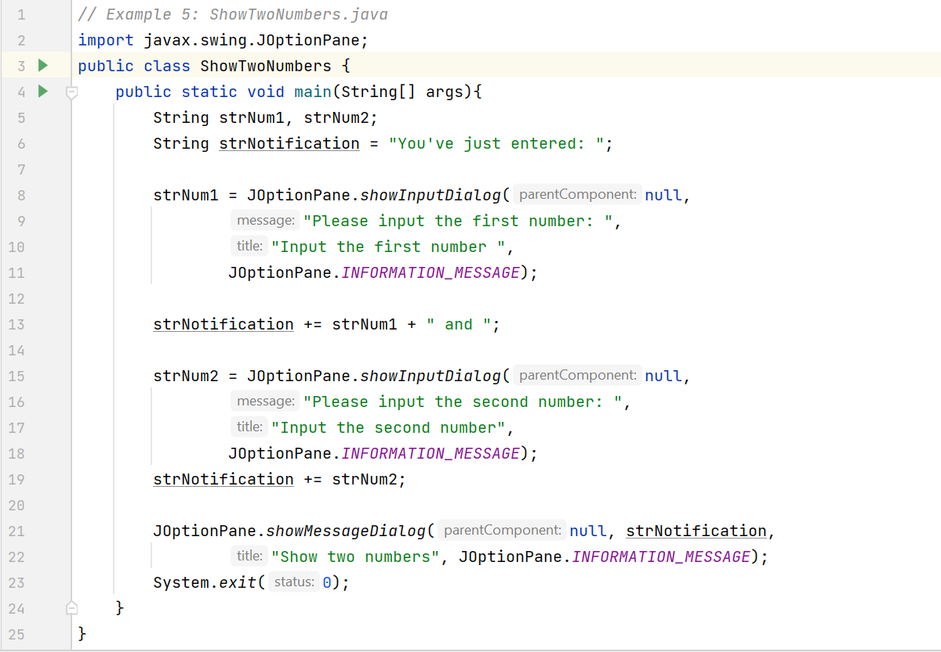

## 2.2.5 Write a program to calculate sum, difference, product, and quotient of 2 double numbers which are entered by users.

**Notes**

* To convert from String to double, you can use

**double num1 = Double.parseDouble(strNum1)**

* Check the divisor of the division

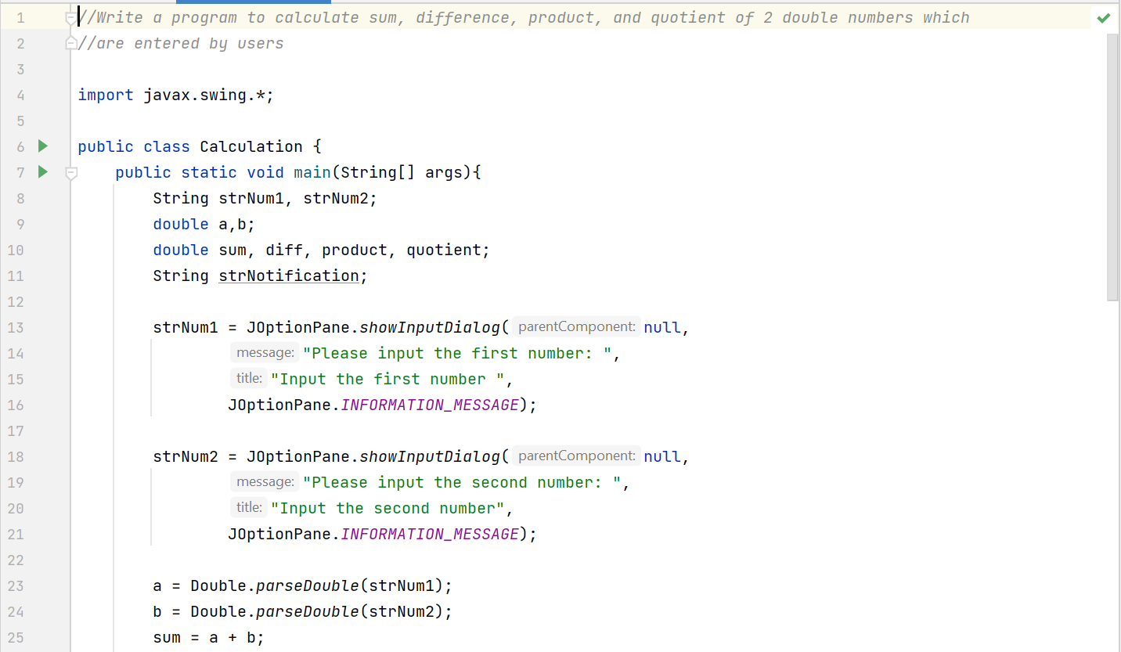

## 2.2.6 Write a program to solve:

1. The first-degree equation (linear equation) with one variable:

Note: A first-degree equation with one variable can have a form such as ax + b = 0

(a ≠ 0).

You should handle the case where the user input value 0 for a.

1. The system of first-degree equations (linear system) with two variables

1. The second-degree equation with one variable:

# Exercises:

## 1: ChoosingOption:

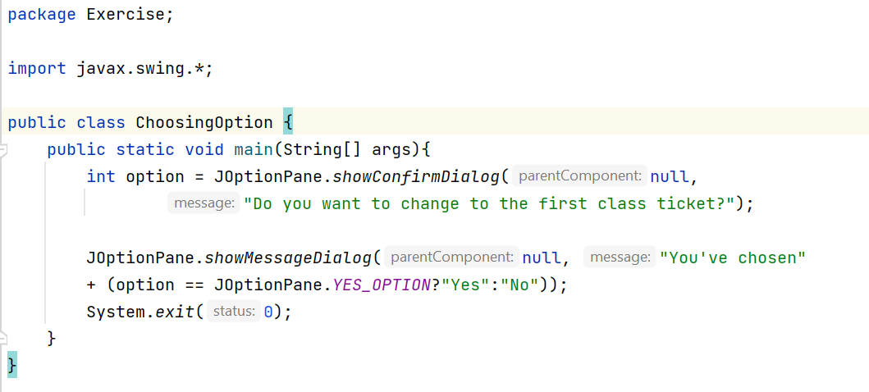

**Choose “Cancel”:**

**Fix the bug: JOptionPane.YES_NO_OPTION**

## 2: Write a program for input/output from the keyboard:

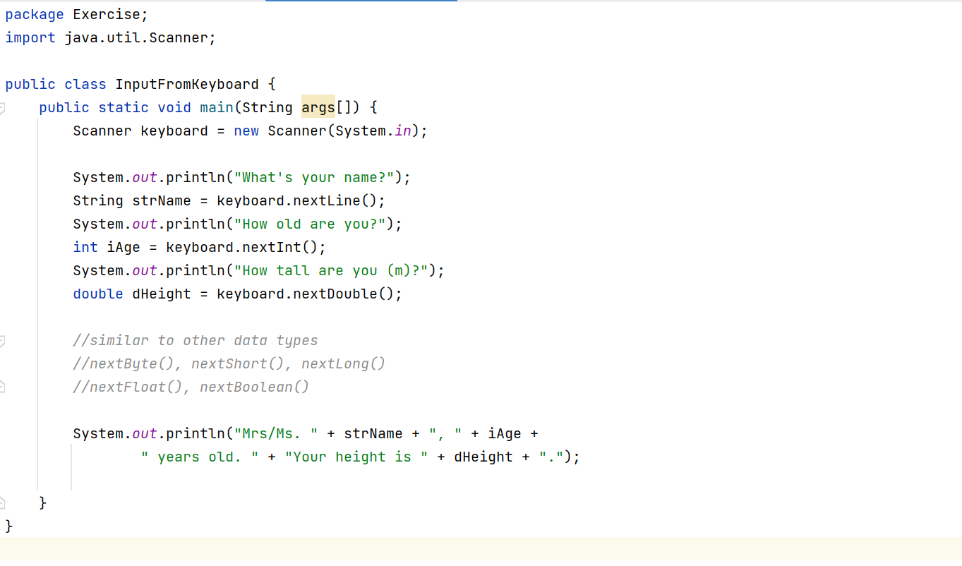

## 3: Write a program to display a triangle with a height of n stars (*), n is entered by user:

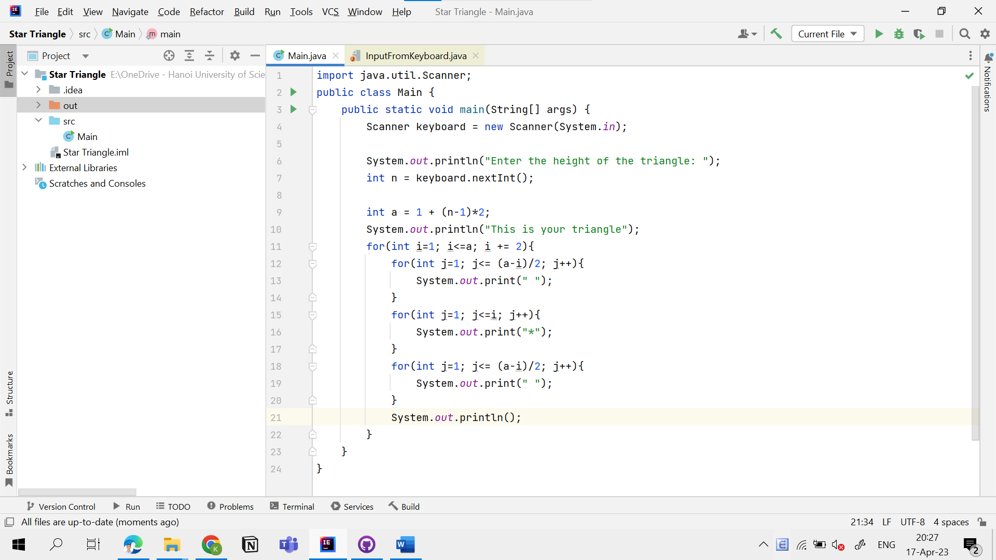

## 4: Write a program to display the number of days of a month, which is entered by user (both month and year). If it is an invalid month/year, ask the user to enter again:

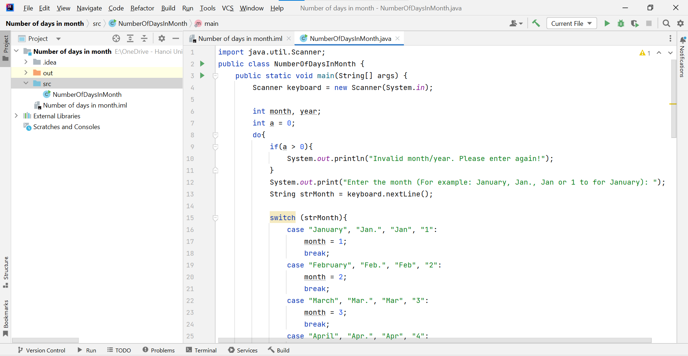

## 5: Write a program to sort a numeric array, and calculate the sum and average value of array elements:

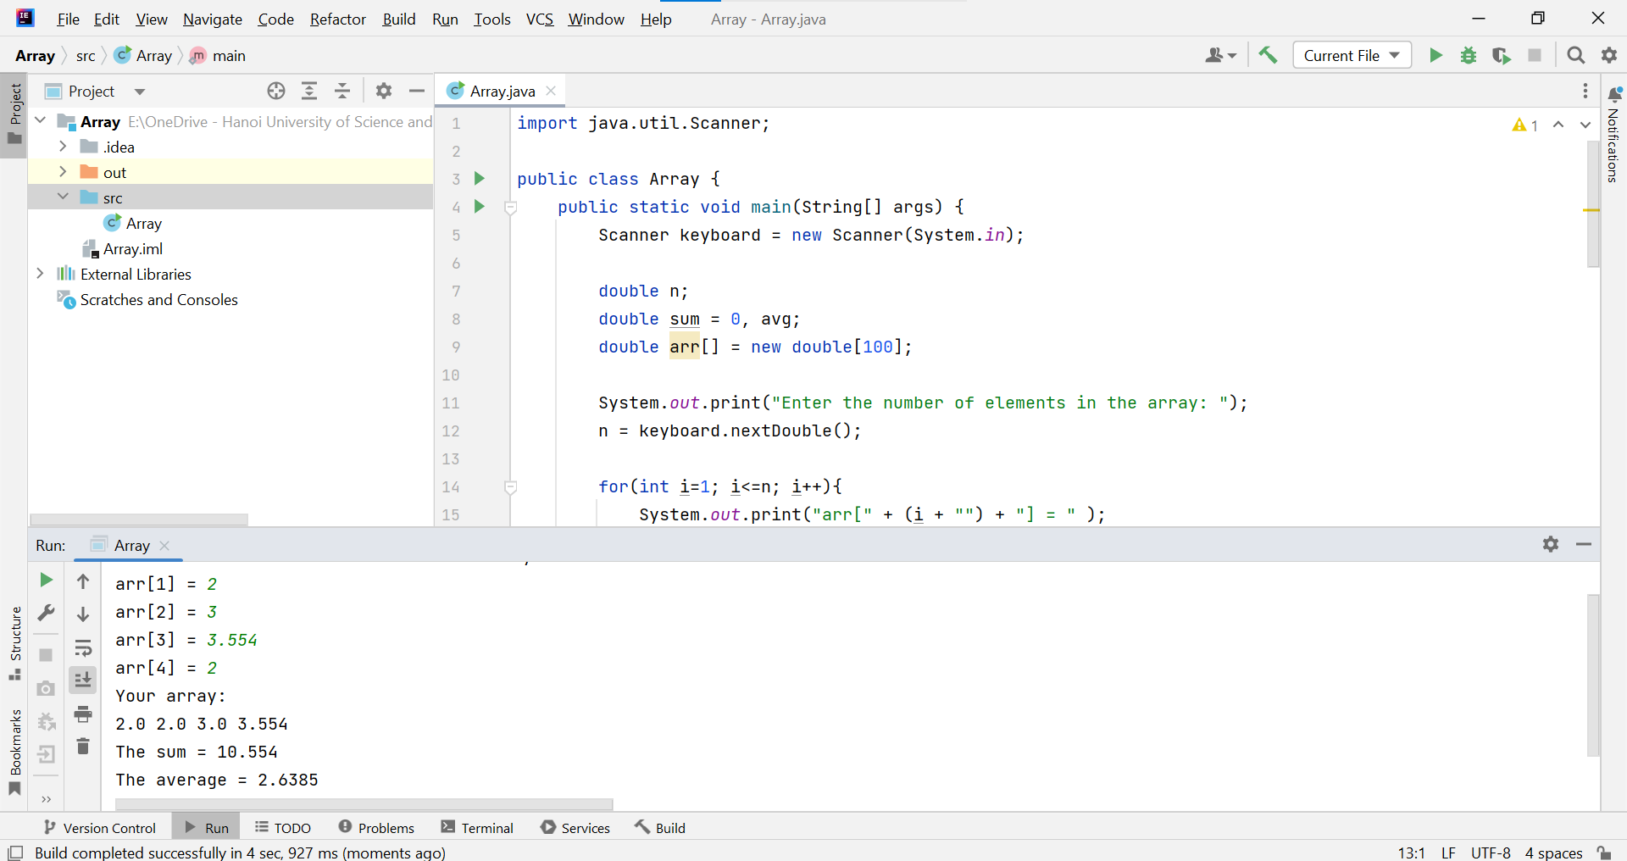

## 6: Write a Java program to add two matrices of the same size:

